Respawn
First, to find the Scripts and prefabs for the respawn: Assets > AAA_FalllenFate > Scripts > ScriptsForRespawn. In this folder it has the scripts and prefabs. The prefabs have the assigned scripts to them.
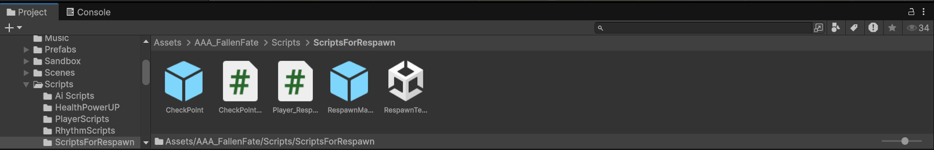

For this to work all you need is the two prefabs (CheckPoint and RespawnManager), PlayerRoot prefab, and something to damage the player’s health.

The respawn is simple. You drag the checkpoint prefab to any where you want checkpoints and make sure the player can enter the trigger area.

As for the respawnmanager only put one in the scene and make sure the tag is “Respawn”. The variables in the RespawnManger will update every time you enter the checkpoints trigger.

Note: Once you enter a checkpoints trigger the trigger will deactivate for that checkpoint.

